Owings Homework Three

Application Integration AWS Lambda and Amazon API Gateway

23 April 2021

UMGC SDEV 400 7380

Professor Craig Poma

# Part 1: Using your AWS Educate classroom environment, create a REST API with a Lambda backend service.

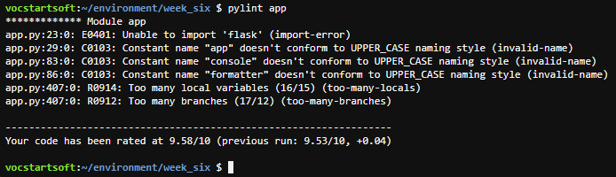

Figure : Pylint Score

The content associated with this week’s lessons were based more on a hand on, go to the AWS service area of Lambda and the API gateway and create the required items for the assignment. Using the cloud9 IDE and the serverless framework (combined with professor Poma’s video) to build everything was much easier since everything is edited in one place to include any required libraries.

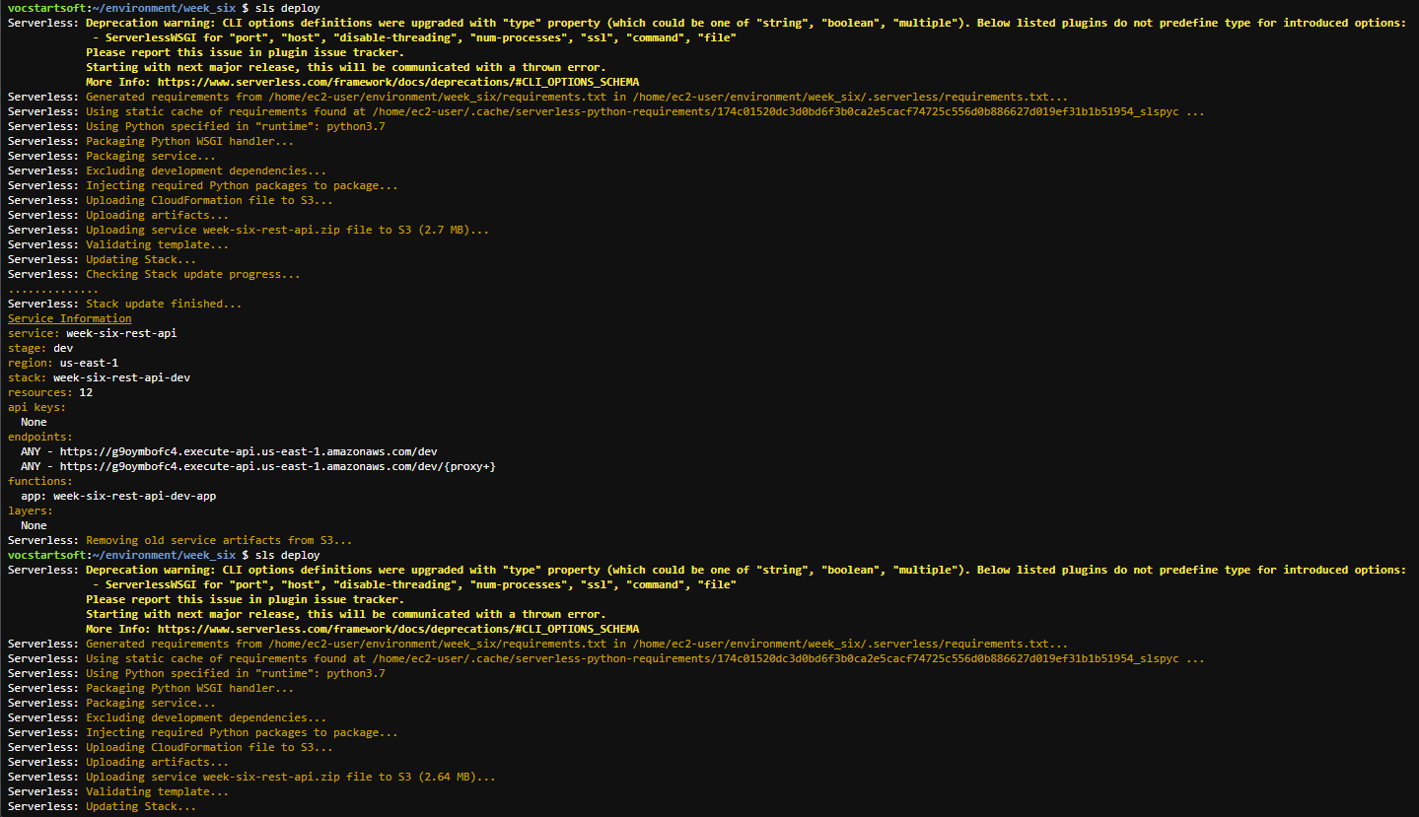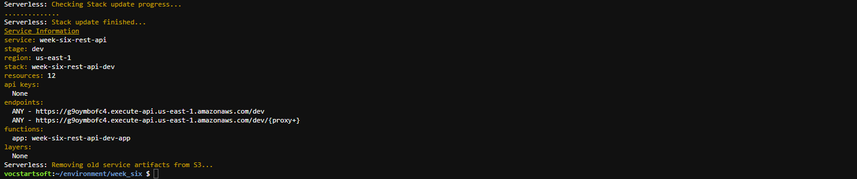

**Endpoint URL:** <https://g9oymbofc4.execute-api.us-east-1.amazonaws.com/dev>

|  |  |  |  |  |
| --- | --- | --- | --- | --- |
| Test Case | Input description | Expected Output | Actual Output | Pass? |
| Test Case 1 | Enter endpoint URL into browser, then navigate to the help link. | An initial page should come up requesting a sport and team name. After coping the help page and pasting into browser a help page should come up. | See screenshots | Yes |
| Test Case 2 | From help link page copy and paste to load up the three sport lists. | Should load lists of 32 NFL teams for football, 30 MLB teams for baseball and 62 college football teams. | See screenshots | Yes |
| Test Case 3 | Copy and paste the three examples give on the help page. | Should load KC Chiefs NFL scores, KC Royals MLB scores and MU college football scores. | See screenshots | Yes |
| Test Case 4 | Enter soccer as sport_type. | Should display link to help page which will show the three sport types. | See screenshots | Yes |
| Test Case 5 | Enter dog for team_abbr for football. | Should notify user to try another team abbr. | See screenshots | Yes |
| Test Case 6 | Pictures of API resources | Required Item, these items can be tweaked via the “serverless.yml file. | See screenshots | Yes |
| Test Case 7 | Pictures of API stage | Required Item | See screenshots | Yes |
| Test Case 8 | Pictures of Lambda function |  |  |  |

|  |  |
| --- | --- |
| Screenshots | |
| Test Case 1 |  |
| Test Case 2 |  |
| Test Case 3 |  |
| Test Case 4 |  |
| Test Case 5 |  |
| Test Case 6 |  |
| Test Case 7 |  |
| Test Case 8 |  |

References

Amazon Web Services. (2021). *Amazon API Gateway.* Retrieved from https://docs.aws.amazon.com/apigateway/latest/developerguide/welcome.html

Amazon Web Services. (2021). *Amazon Web Services - Documentation.* Retrieved from https://github.com/awsdocs

Amazon Web Services. (2021). *AWS Documentation.* Retrieved from https://docs.aws.amazon.com/

Poma, C. (2021). *Using Serverless to automate Lambda and API Gateway Deployments.* Retrieved from https://learn.umgc.edu/d2l/le/news/552070/2201619/view

Python Software Foundation. (2021). *The Python Language Reference.* Retrieved from https://docs.python.org/3/reference/